

AWS WEBINAR ASSIGNMENT

Face Detection Application



April 2, 2020

**p HARSHAVARDHAN**

1St Year Electronics And Communication Engineering, Sri Venkateswara College of Engineering, Sriperumbudur

**I) AWS:**

1)AWS Login screen with username:

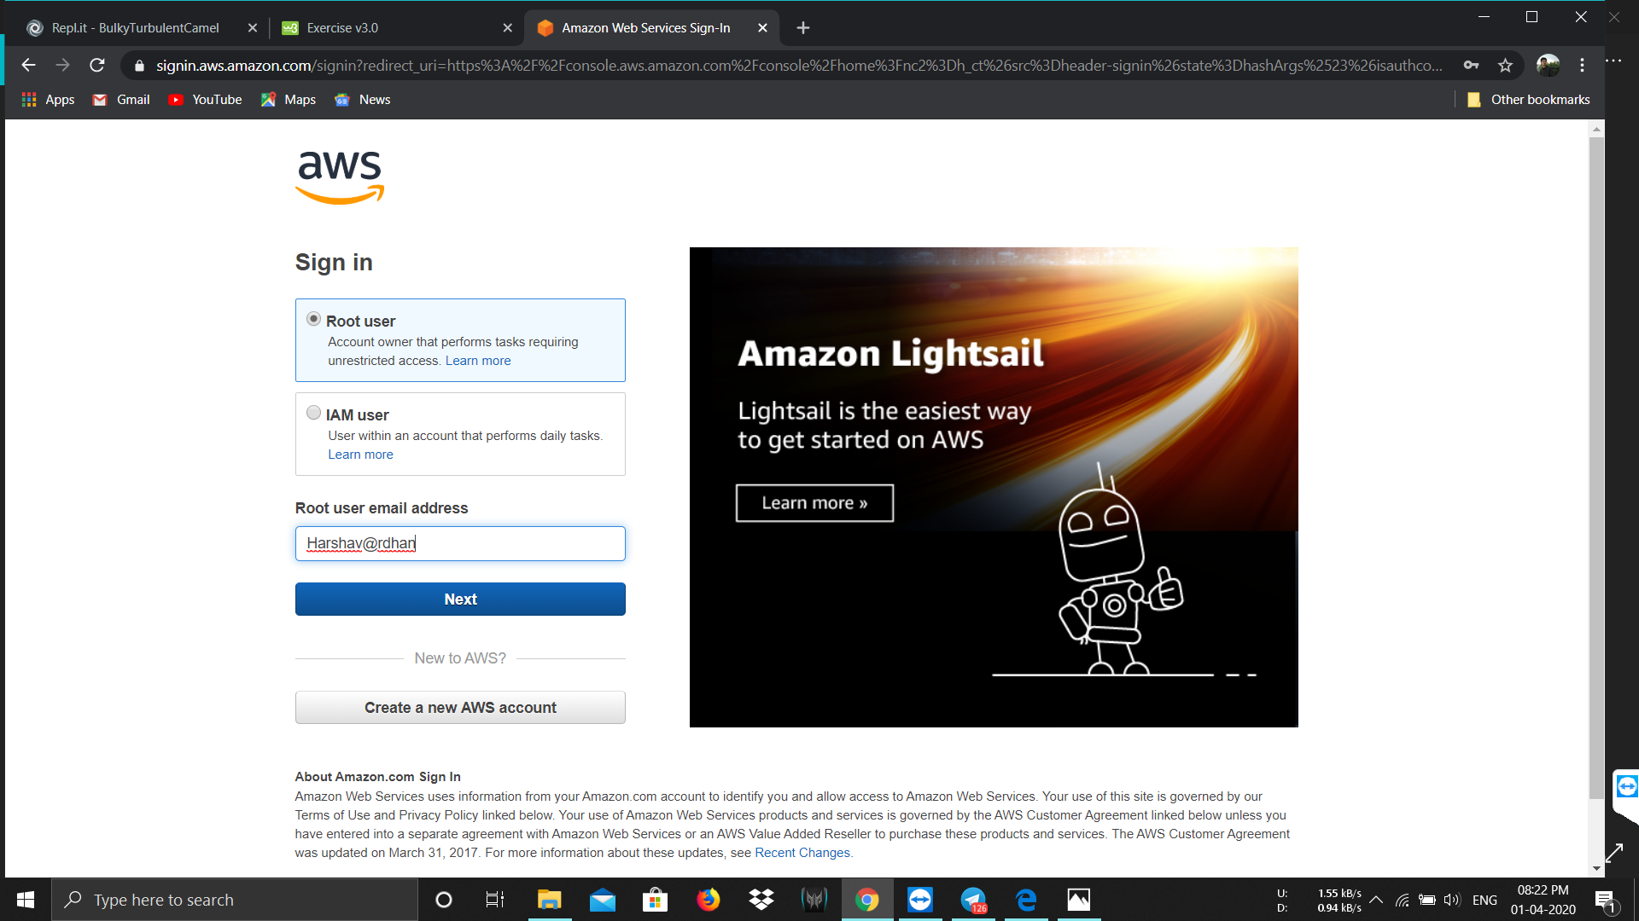

1. EC2 Dashboard:

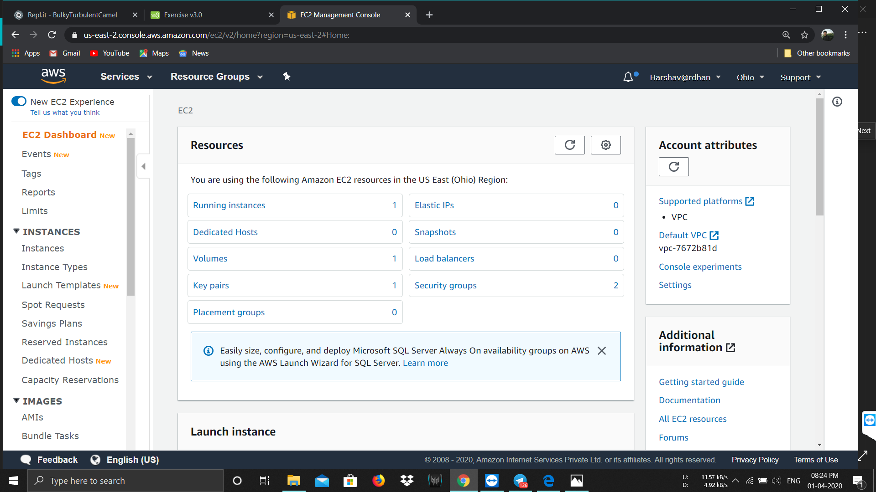

1. S3 Dashboard:

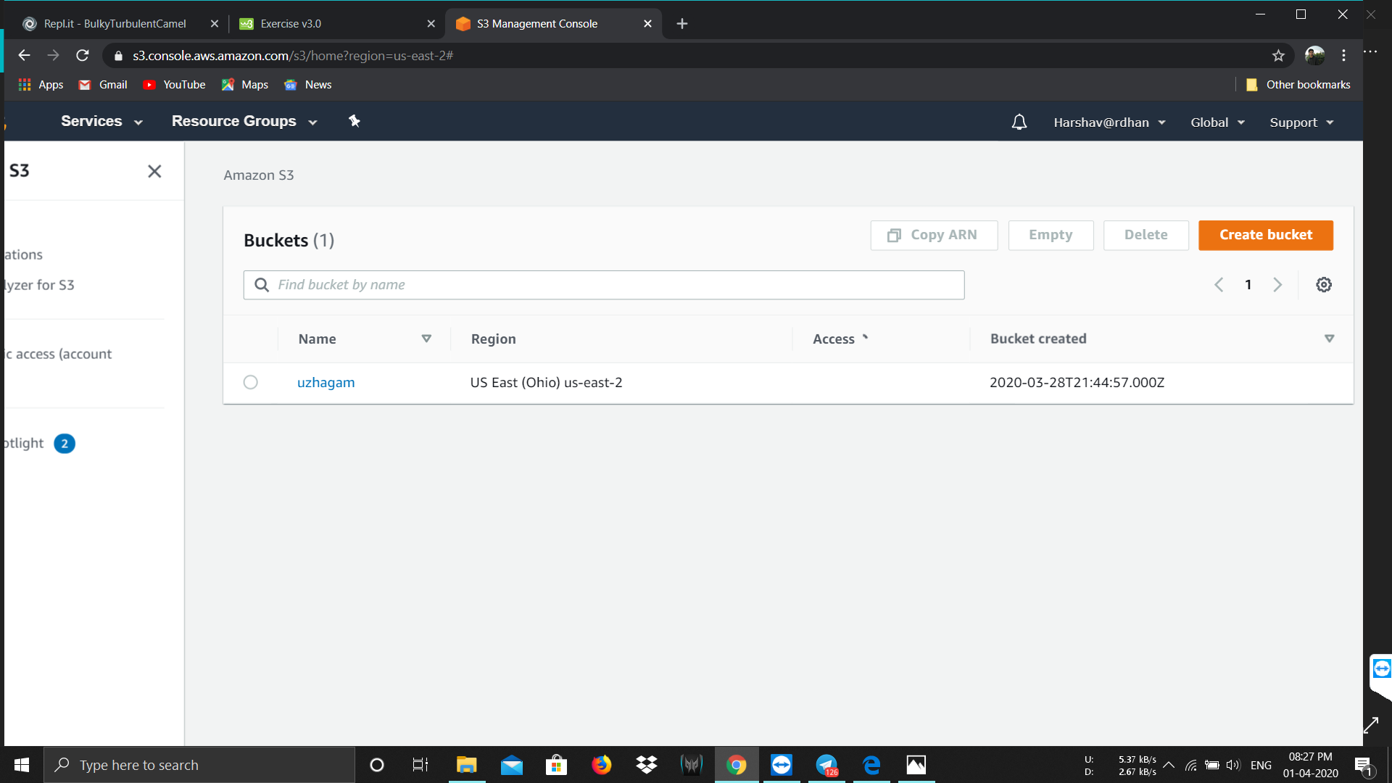

4) Rekognition Dashboard:

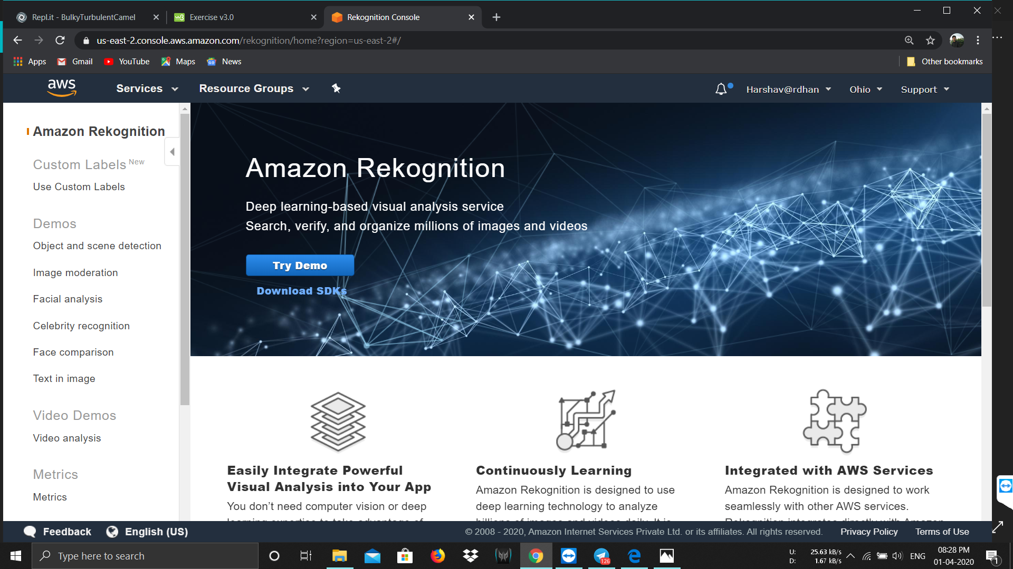

**II) EC2:**

1)Choosing an AMI:

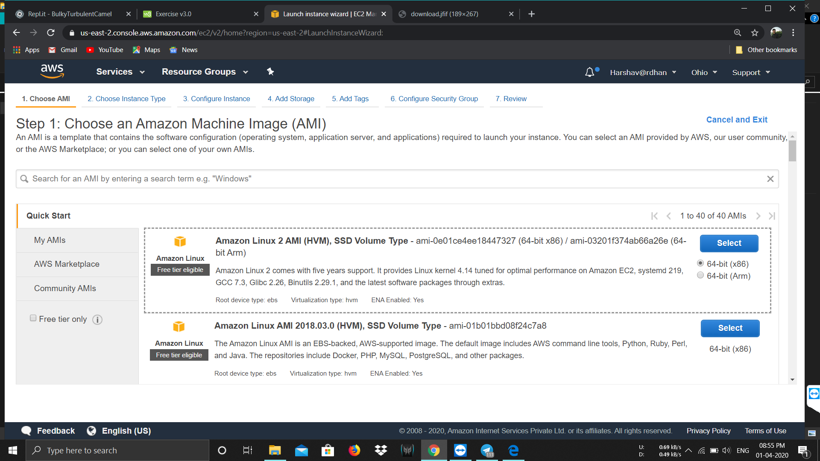

1. Choosing an Instance type:

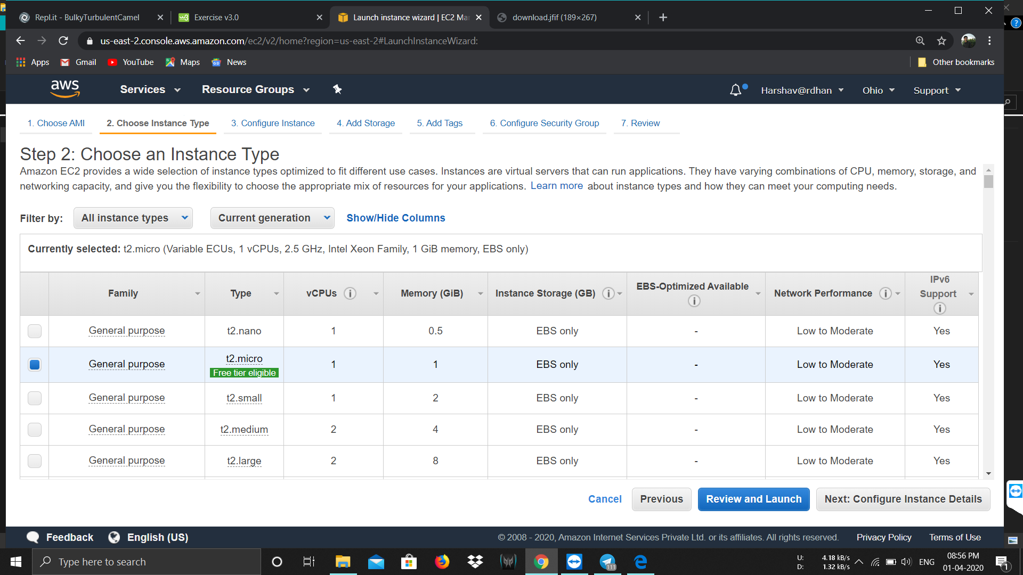

1. Adding Storage:

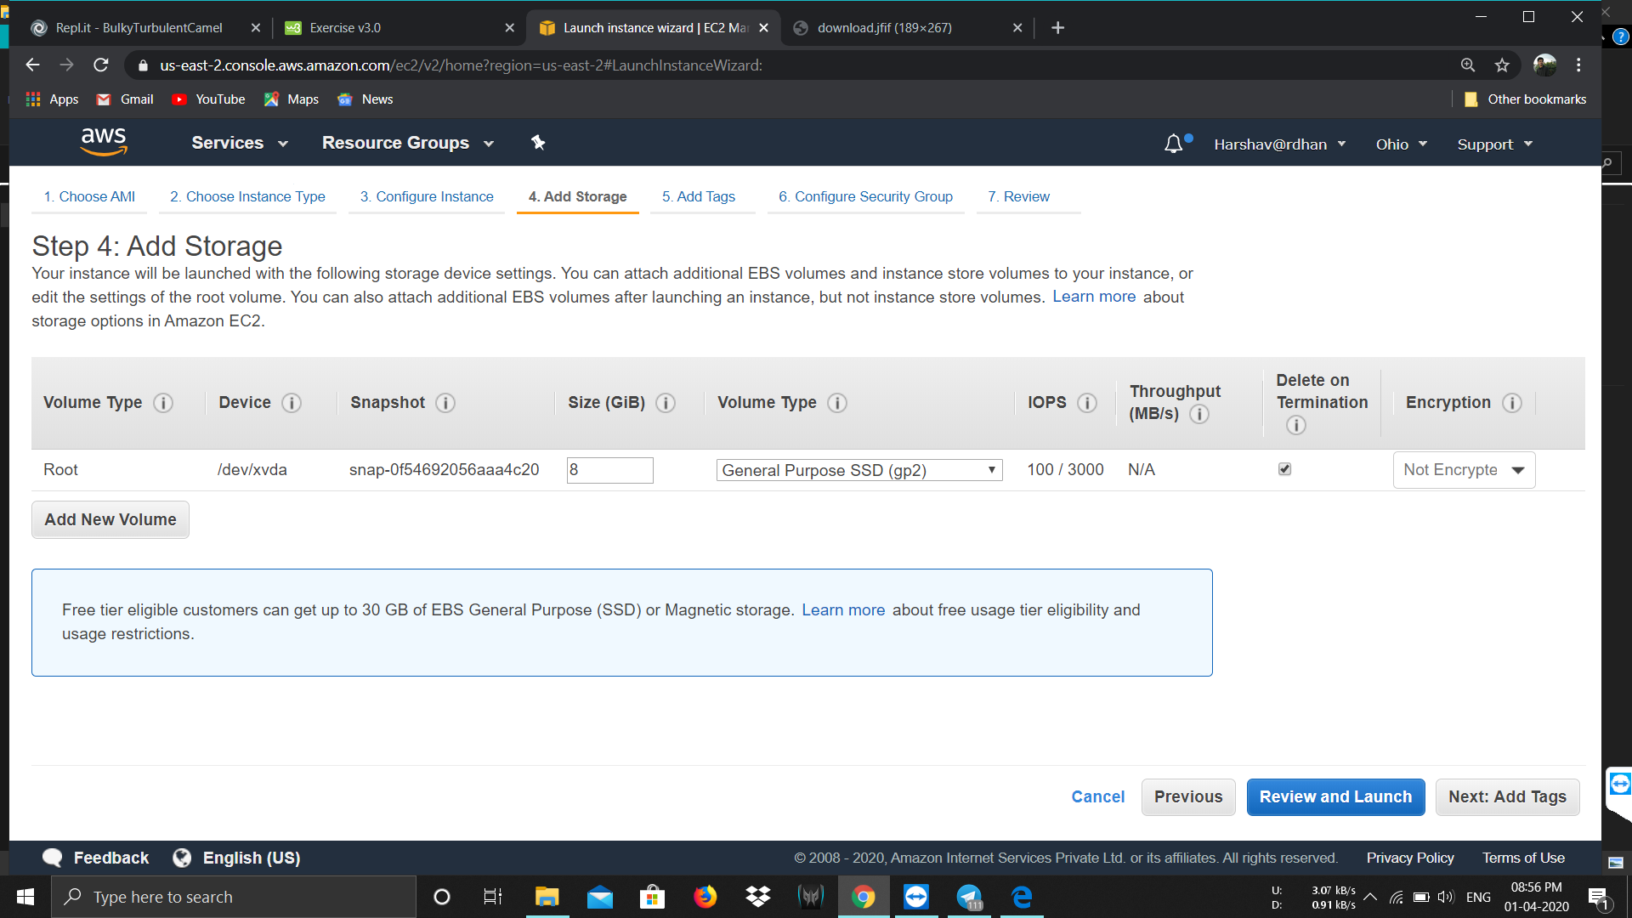

1. Configuring Security Group:

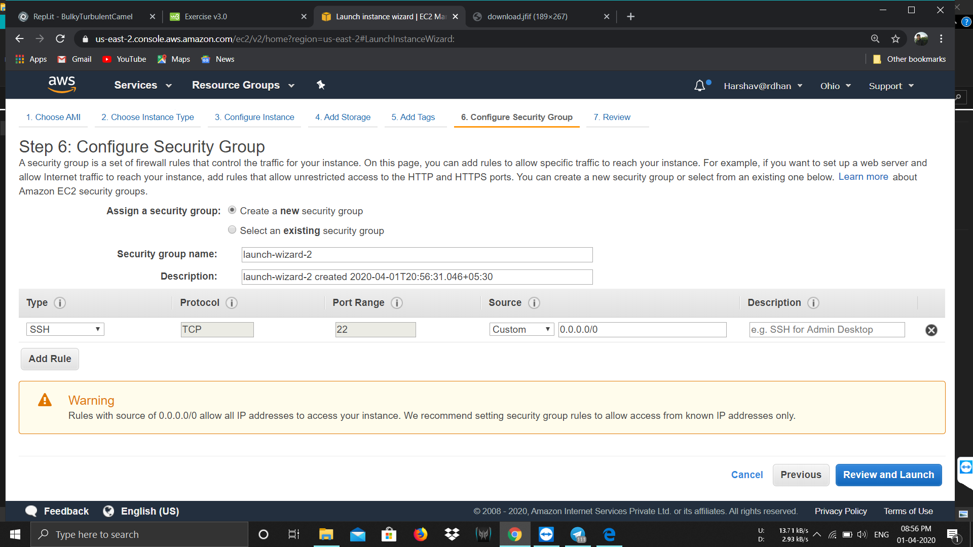

1. Key Pair Download:

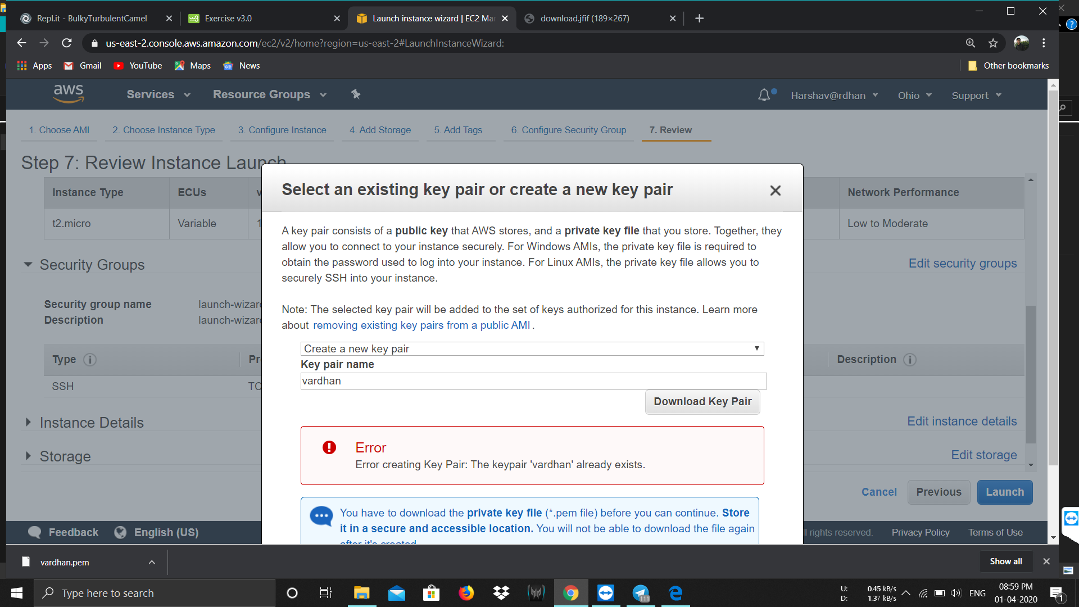

1. PuTTYgen conversion from .pem to .ppk file:

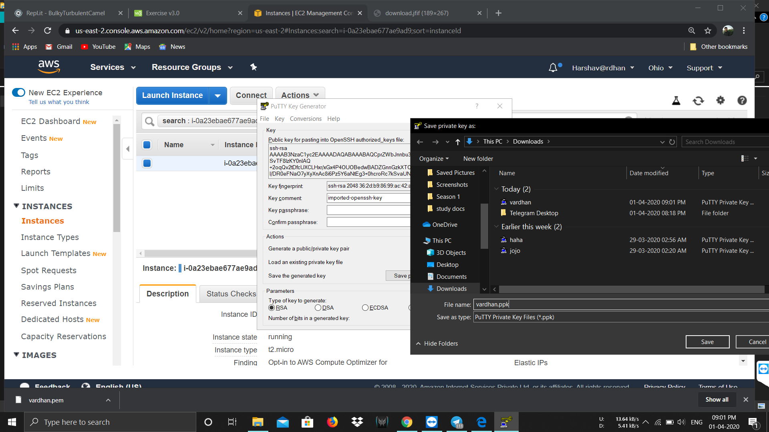

7) Logged in EC2 Blackscreen:

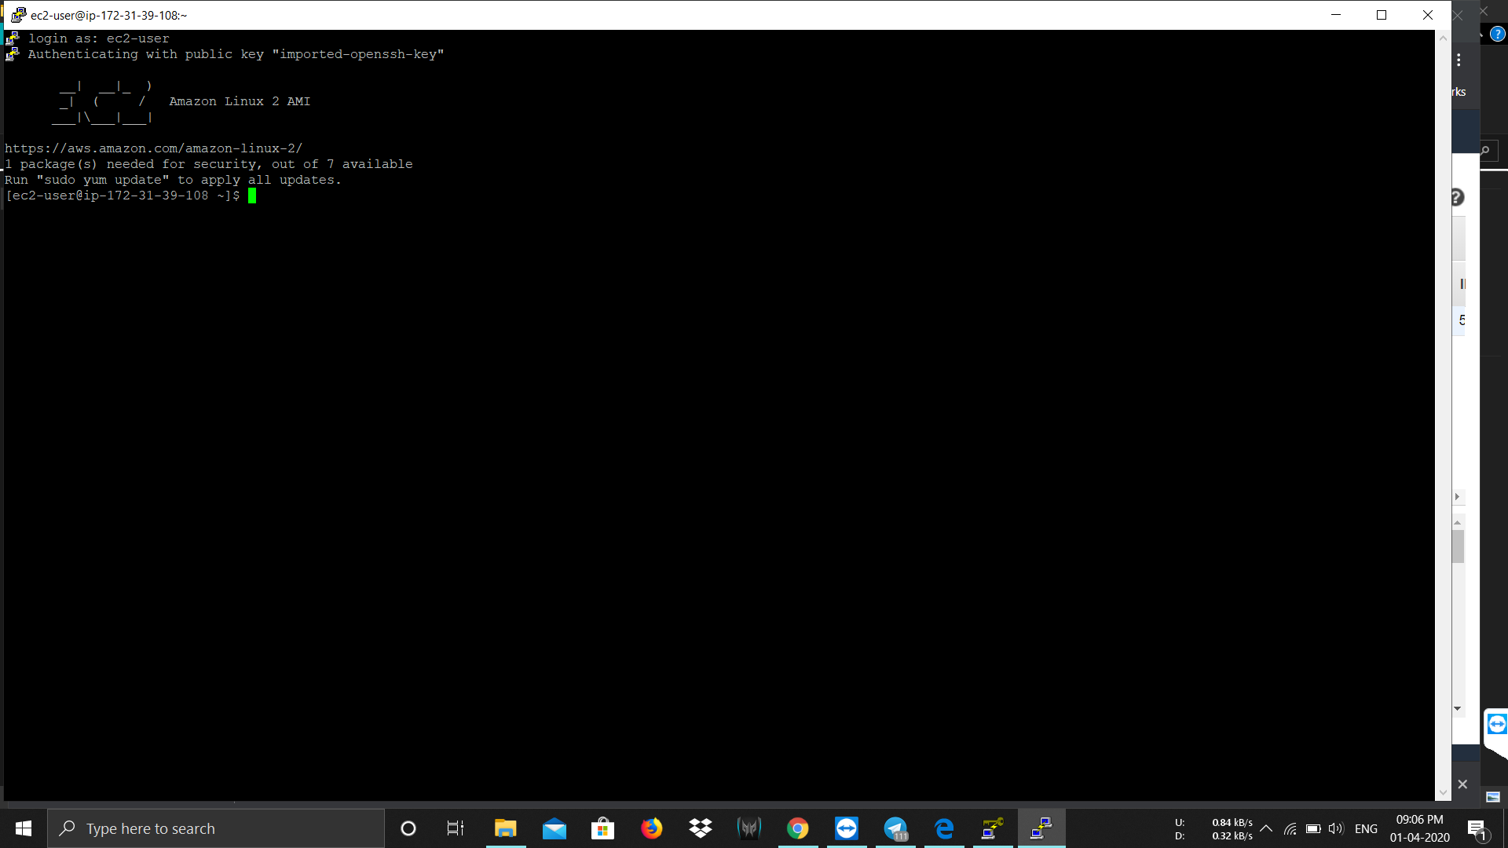

**III) S3:**

1) Creating a bucket:

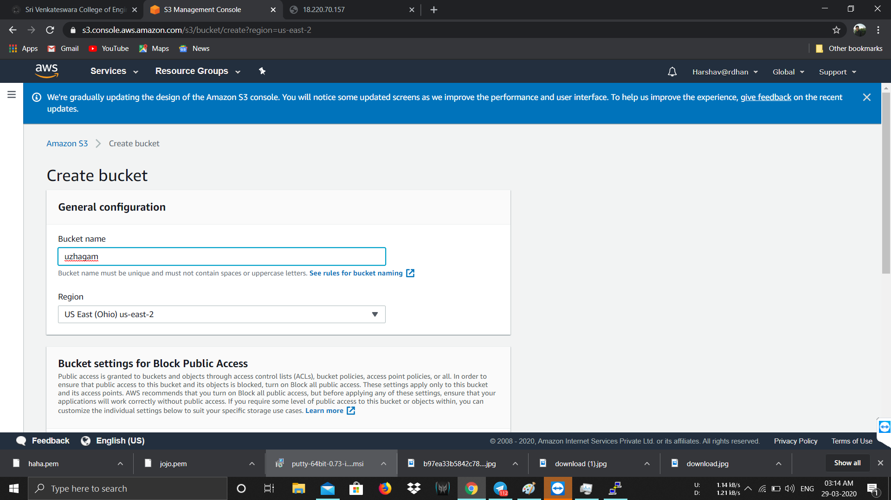

1. Uploading an object:

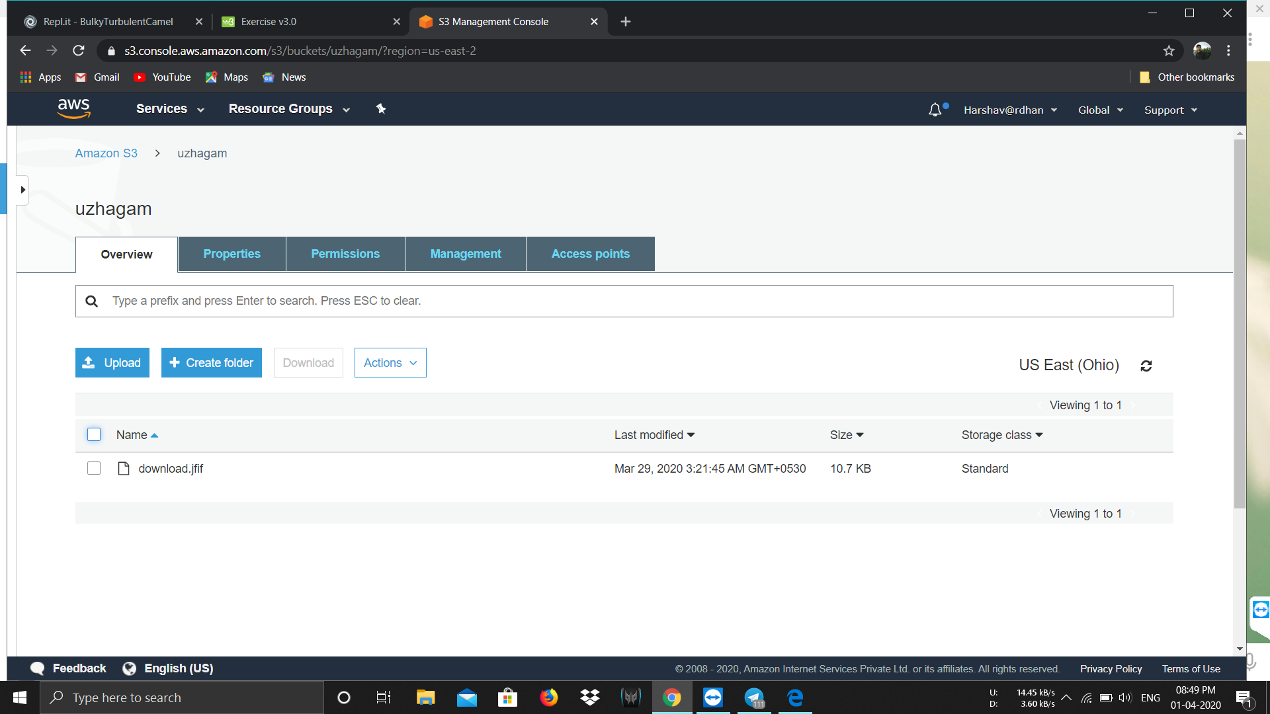

3)Enabling Static Webhosting:

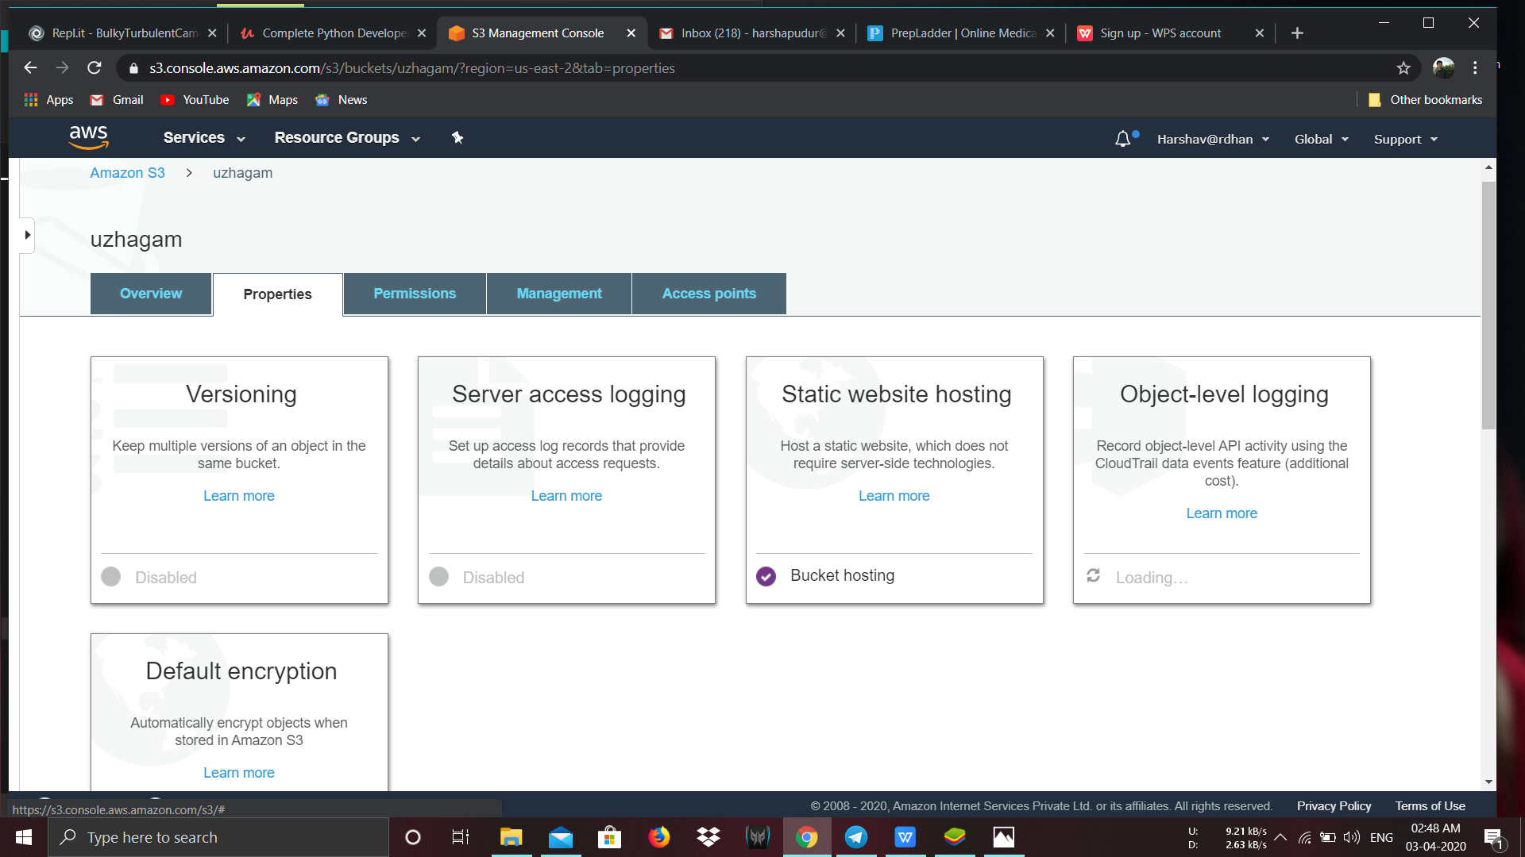

4) Making object Public:

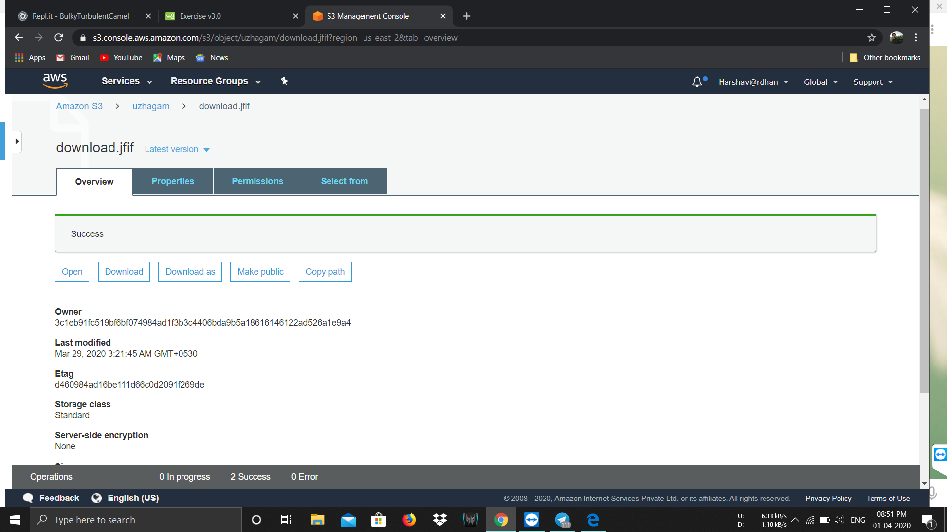

1. Checking S3 link on browser:
2. 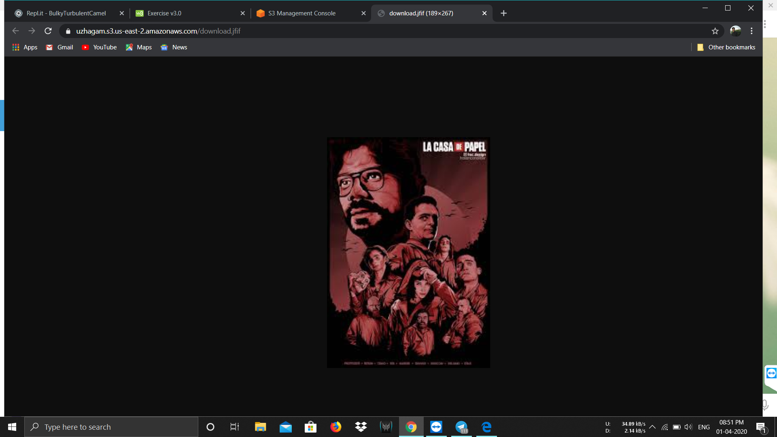

**IV) Rekognition:**

1) Face analysis:

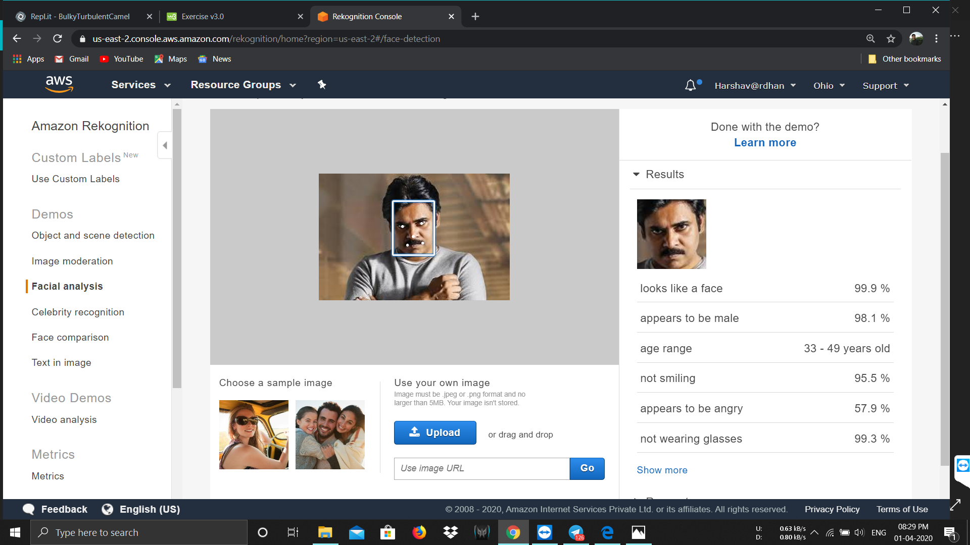

1. Celebrity Recognition:

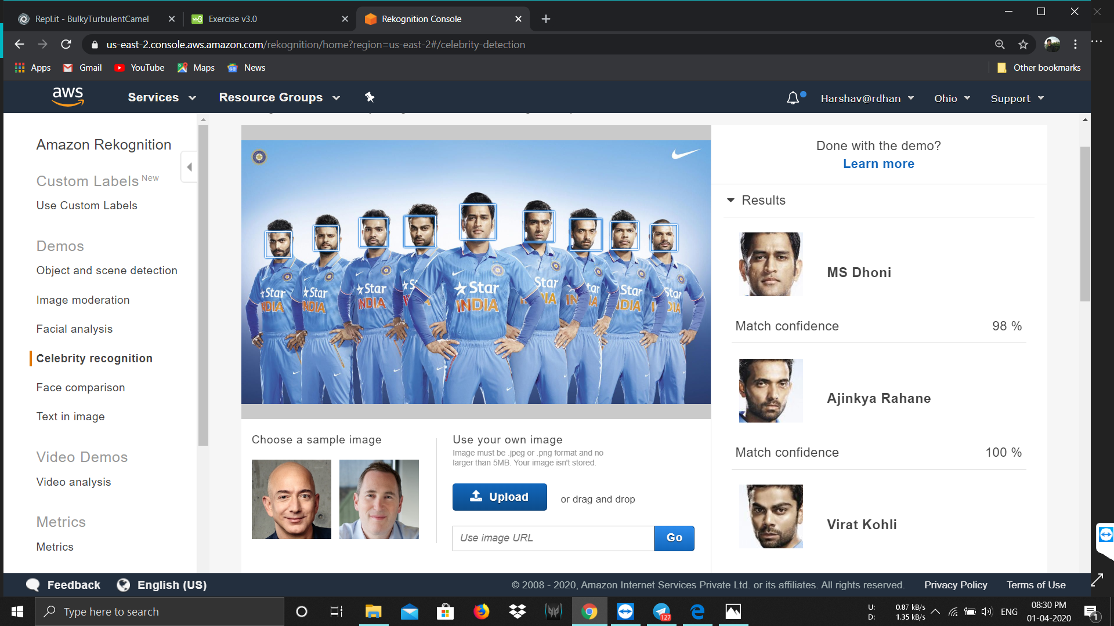

1. Face Comparison:

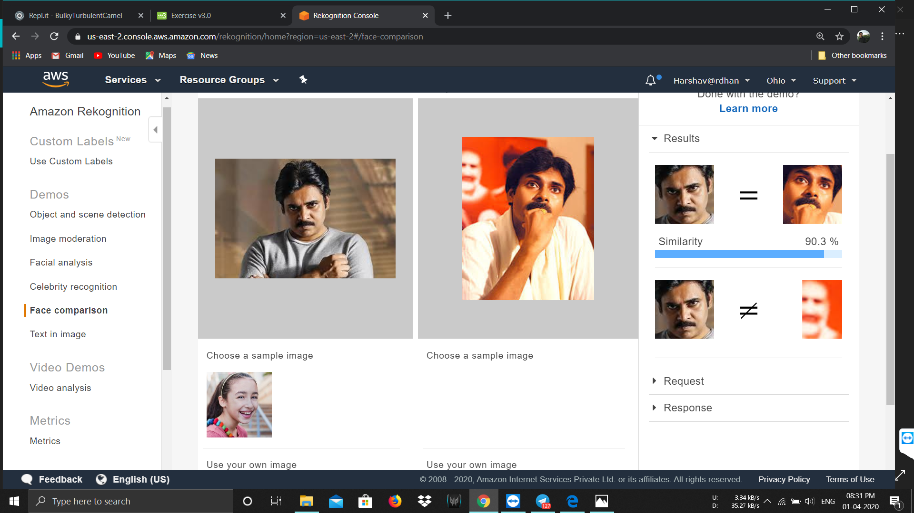

4) Text in Image:

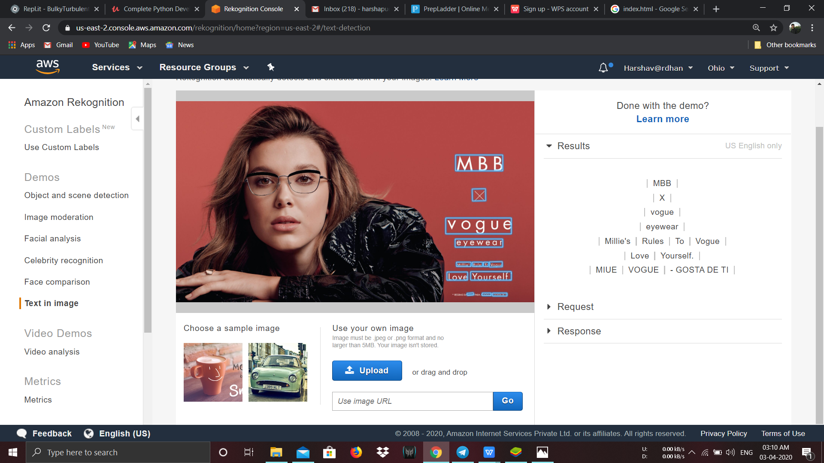

**V) EC2 & S3:**

1) Installing aws-sdk:

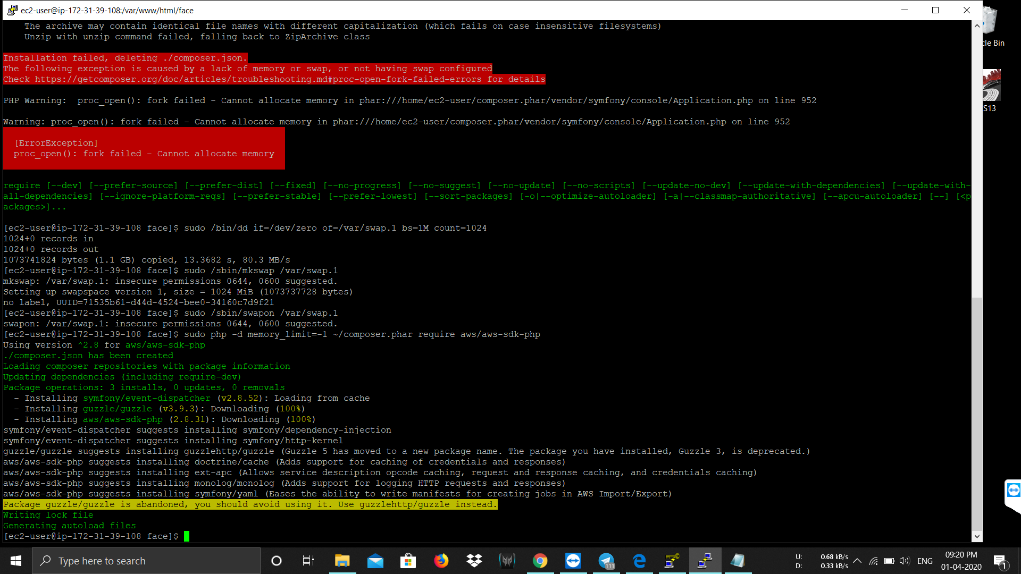

2) Installing php: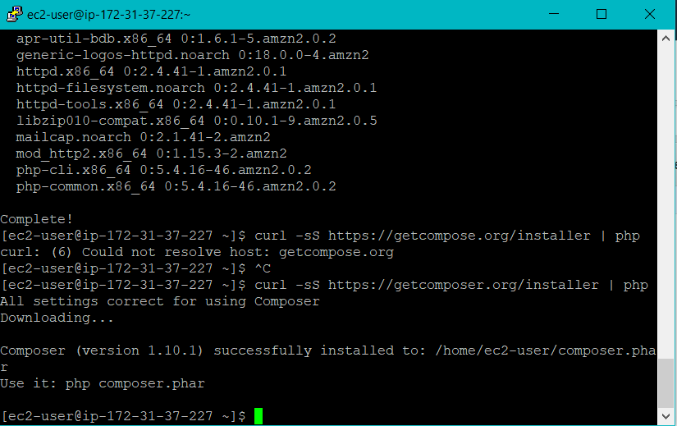

3)Code inside index.php:

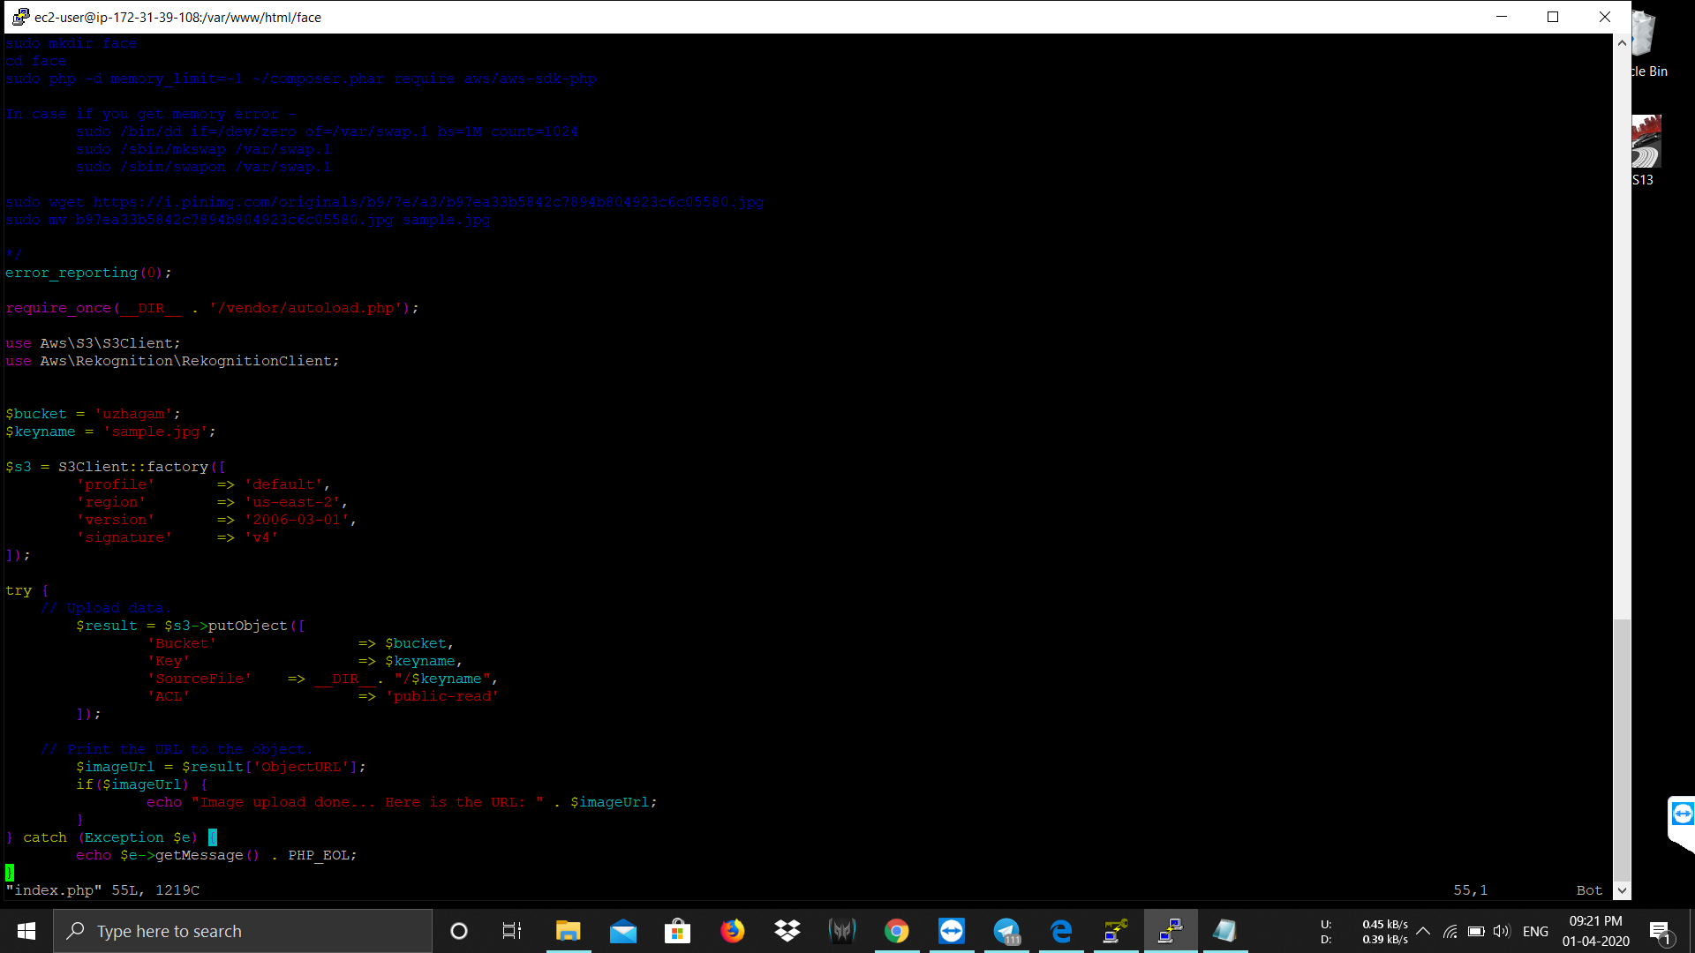

4) Upload successful message:

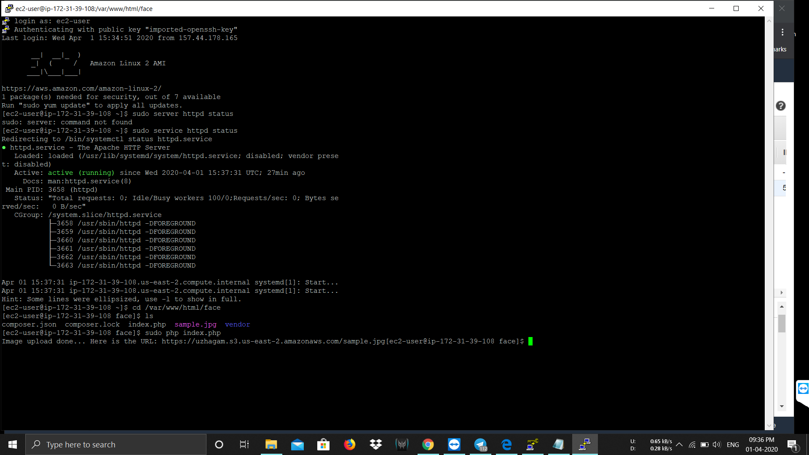

**VI) EC2 & Rekognition:**

1) Face detection successful:

